**Linux Administration Essentials ASS-4**

**Assignment Day 8**

**Assignment 0**

**1. Create a simple shell script to tell the user about their session – they need to know: ● What their username is ● What the current date is ● What the time is ● What their current working directory is ● How many files they have in that directory ● What is the biggest file in their current directory**

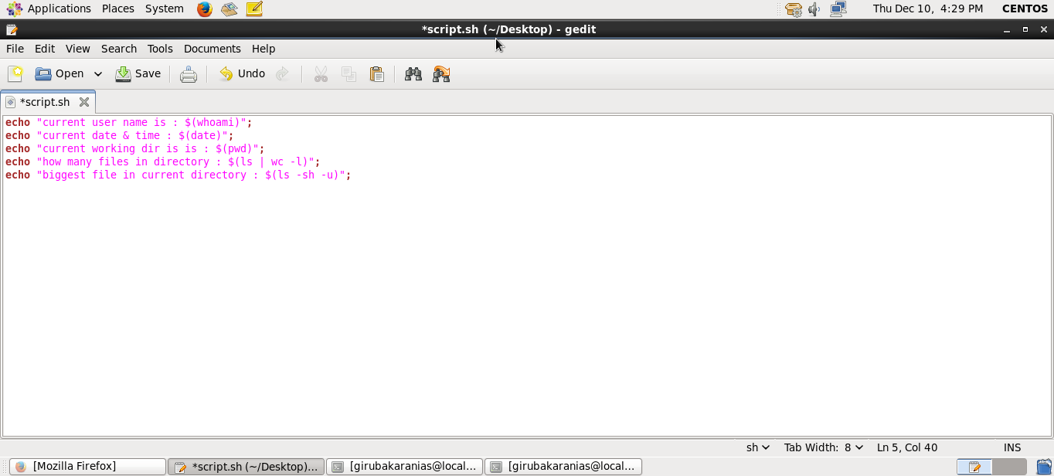

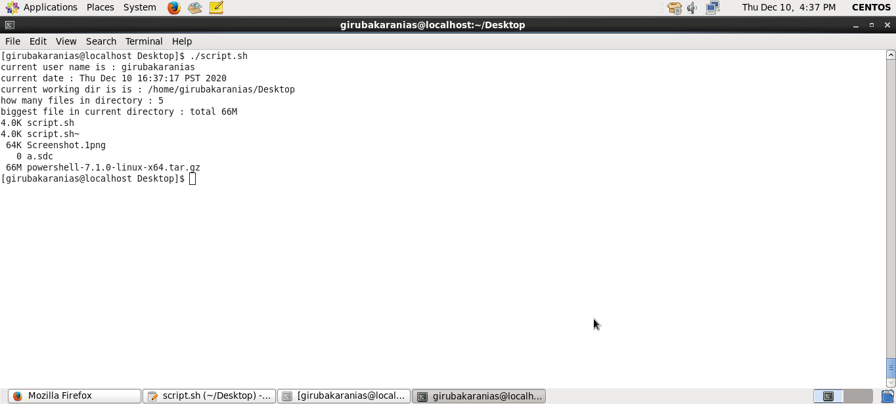

**Assignment 1**

**Create a directory with a few test files in it (the files can be empty). Now write a script that for every file in that directory you rename it to have an extension of today's date in YYYYMMDD format**

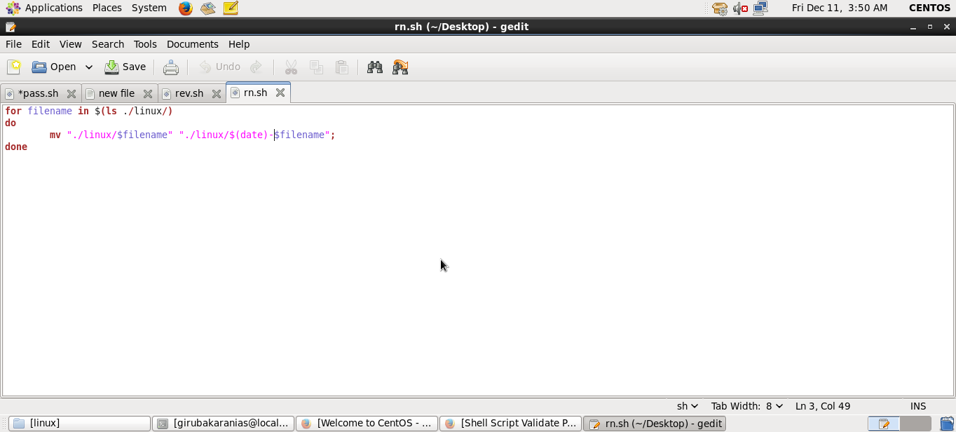

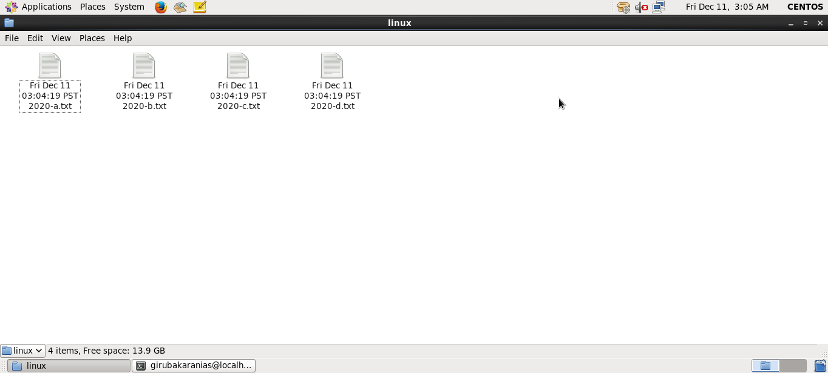

**Assignment 2**

**Write a script that takes a number as an input and reverses it out to the user. For example, if the original number is 74985, the output should be 58947.**

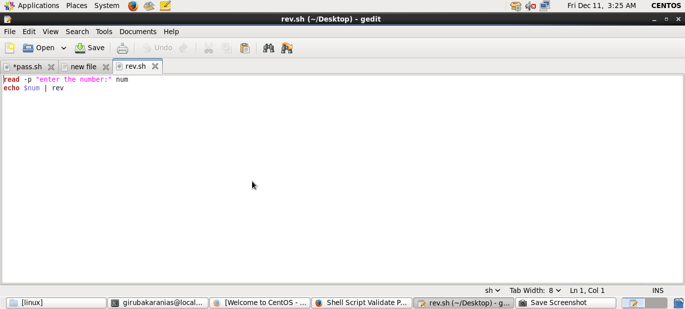

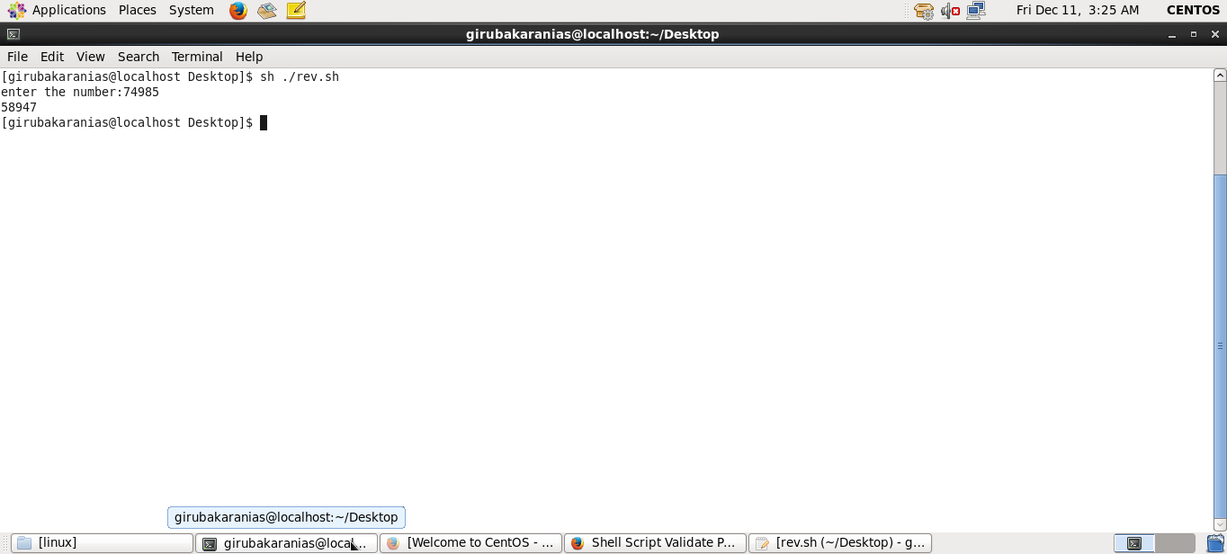

**Assignment 3**

**Write a script to validate how secure someone's password is. Things you would care about: ● Length should be 8 or more characters ● The password should contain numbers and letters ● There should be both uppercase and lowercase letters**

